LEVEL 3 FLOOR (1)
Handstand (for walkover, handspring and flic flac) | 1. Handstand with nose against wall – looking at hands – covering ears, hips open, bottom squeezed. Push “tall” up the wall – 40 secs
 | 2. F2-1.6 Handstand with feet touching a bar – hold for 20-30 sec | 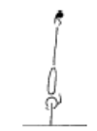 | - arms straight  - chest rounded, extended through the shoulders  - hips open  - gluteal muscles squeezed  - head neutral  - maintain good body tension and alignment
 | 3. F2-1.7 Handstand walking | 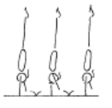 | - arms straight  - chest rounded, extended through the shoulders  - hips open  - gluteal muscles squeezed  - head neutral  - maintain good body tension and alignment
 | 4. F2-1.8 Handstand ½ turn – recommend 2 hand placements per turn | 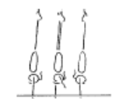 | - arms straight  - chest rounded, extended through the shoulders  - hips open  - gluteal muscles squeezed  - head neutral  - maintain good body tension and alignment
 | 5. Handstand holding on to object hanging from rings
 | 6. Handstand against horse
 | 7. Handstand on parrallettes
 | 8. Split handstand against box/wall
 | 9. F2-1.2 From squat perform a small jump to tuck, straddle or pike handstand
 | 10. Split handstand against box/wall
Handstand Fwd Roll | 1. Handstand fwd roll to L-sit, reach fwd to pike stretch, candlestick, roll to stand
 | 2. ® © High fwd kick – handstand forward roll | 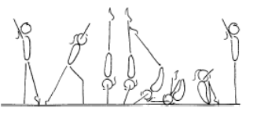 | - kick to a vertical handstand  - head neutral  - hips open  - use pressure on the finger tips to place the body off balance  - maintain a straight body during the falling phase  - keep arms straight and chest in  - tuck head under and roll in a tight tuck position
 | 3. F3-2.4 Fwd roll to tuck handstand, fwd roll to straddle handstand, fwd roll to pike handstand fwd roll series | 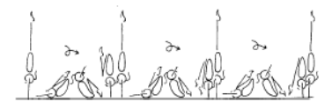
 | 4. ®* Handstand “pop” fwd roll
Cartwheel / Roundoff | 1. Lying on back on floor – start in star position and turn hips/shoulders ¼ turn each way to learn ¼ turn
 | 2. Against a wall – cartwheel to stop in handstand – coach assists gymnast to ¼ turn and step down

LEVEL 3 FLOOR (2)
Cartwheel / Roundoff  Con’t | 3 ® © From feet together, jump to hurdle, cartwheel, cartwheel step in (snap up) | 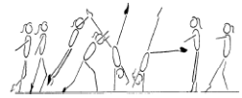 | - start with square hips and shoulders in the direction of travel  - lunge into the cartwheel maintaining square posture  - kick to a vertical side handstand with a small straddle  - first hand is placed same as a side cartwheel and becomes the support and rotational hand  - second hand is turned a 1/4 turn and placed pointing towards the first hand and becomes the repulsion hand  - head neutral  - body rotates 1/4 turn so that shoulders and hips are now square and facing the direction of travel  - head is neutral and eyes can see where the foot is about to land  - keep arms straight and chest in  - once the body is vertical over the second hand the chest lifts and the feet come down causing a ‘see-saw’ illusion  - the shoulders must not go past the vertical line  - finish in a stand with arms forward low horizontal  - chest in, hips open
 | 4. F4-2.5 Perform a roundoff from a rebound surface to a lower landing surface – to feet | 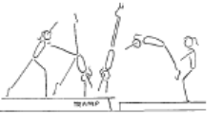 | - ensure the body remains within the vertical plain, no pike or arch action  - maintain good body tension and alignment  - repulsion from hands occurs during the vertical phase when the body is travelling upwards with the heel drive  - land in a dish shape with arms forward low horizontal
 | 5. Corbett snapdowns from a beatboard or box – rebound on landing | 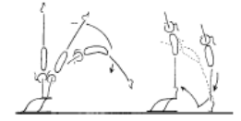 | - maintain body tension and alignment  - head neutral  - hands slightly turned in  - shoulders remain over the initial support position  - bounce from the floor
 | 6. F4-2.7 Perform a roundoff over a shape | 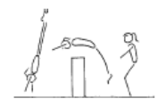 | - ensure the body remains within the vertical plain, no pike or arch action  - maintain good body tension and alignment  - repulsion from hands occurs during the vertical phase when the body is travelling upwards with the heel drive  - land in a dish shape with arms forward low horizontal
 | 7. F4-2.8 Run roundoff from a board to land in a rebound against an incline mat | 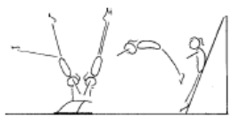 | - ensure the body remains within the vertical plain, no pike or arch action  - maintain good body tension and alignment  - repulsion from hands occurs during the vertical phase when the body is travelling upwards with the heel drive  - land in a dish shape with arms forward low horizontal
 | 8. ®* Roundoff | 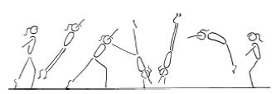 | - start with square hips and shoulders in the direction of travel  - lunge into the round off maintaining square posture  - kick to a vertical position  - first hand is placed same as a side cartwheel and becomes the support and rotational hand  - second hand is turned a 1/4 turn and placed pointing towards the first hand and becomes the repulsion hand  - gymnast must be in line with the first hand  - head neutral  - body rotates 1/4 turn so that shoulders and hips are now square and facing the direction of travel  - head is neutral and eyes can see where the feet are about to land  - keep arms straight and chest in  - once the body is vertical over the second hand the chest lifts and the feet come down causing a ‘see-saw’ illusion  - the shoulders must not go past the vertical line  - finish in a rebound with arms forward low horizontal  - chest in, hips open

LEVEL 3 FLOOR (3)
Backward Roll (for back salto) | 1. ® © Bwd roll to straddle or pike stand, ¼ turn, slide to fwd splits, join legs to sit, lift to side support, kneel, chest to knees, lift chest, kick leg, step up to stand |  | - Legs together  - Smooth rolling action  - Legs and arms straight
 | 2. Bwd roll to candlestick
 | 3. Bwd roll to front support
 | 4. Bwd roll to front support with feet raised on box – gradually raise height of boxes | 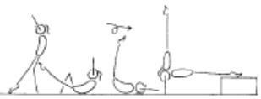 | - maintain body tension and alignment  - head neutral
 | 5. F2-4.5 Back extension roll down an incline to handstand with straight arms (then on the floor) | 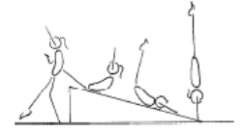 | - maintain body tension and alignment  - head neutral
Stride Leaps | 1. Kicks x 10, hold x 10, pulse at top x 10 – fwd & bwd
 | 2. Step kick & hop – hold leg up – land with bent supporting leg and hold
 | 3. Landing position jumps along beam – back leg held
 | 4. ® © Small arabesque – 2 x stride leaps (series) | 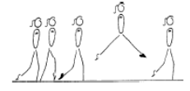 | - square hips and shoulders throughout the skill  - extended toes, ankles and knees  - legs should be level  - head up, eyes down  - arms out to the side, horizontal  - control of body
Leaps/Jumps | 1. ® © Straight jump, rebound to star jump, rebound to jump ½ turn series |  | - Stretched position  - Good height  - Quick and even rebound between jumps  - Legs and toes stretched
Body Wave | 1. F3-1.3 Standing at the ballet bar or beam, holding on, perform a backward body wave and fwd body wave.
 | 2. F3-1.4 Start on knees – perform a backward and forward body wave with arms moving rhythmically in a bwd or fwd circle
 | 3. ® © Begin in 4th position – back leg pointed, Forward Body Wave |  | - Must demonstrate full contraction and wave action  - Head release  - Control shown throughout movement
Turns | 1. 360’ pivot on 1 foot
 | 2. ® © 360’ pivot on 1 foot, ½ turn on 2 feet |  | - Good passé position  - Straight supporting leg  - Turns on relevé  - Straight posture  - Turn entire body as one
FWO, BWO & Tic Toc | 1. F4-1.2 “rock and roll” in a bridge position | 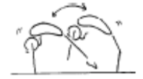 | - feet and hands come off the ground at the peak of each sway  - maintain good body tension and alignment  - keep arms straight throughout the skill  - keep legs as straight as possible  - emphasise the use of hip and shoulder flexibility
 | 2. F4-1.3 Perform a split handstand against the wall | 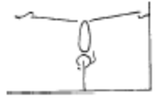 | - maintain good body tension and alignment  - gymnast actively tries to push legs down  - maintain a vertical handstand from hands to hips
 | 3. F2-5.5 From kneel, perform a bridge onto a high raised surface and return to stand
 | 4. Limber from stand – down to bridge and up again

LEVEL 3 FLOOR (4)
FWO, BWO & Tic Toc  Con’t | 5. F2-5.7 Bridge from standing kickover to stand (back limber) | 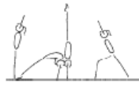 | - keep hips in line with feet  - stretch up first then open shoulders to initiate the bridge  - keep gluteal muscles tight  - maintain good body tension and alignment  - legs straight in the kick over (legs can be together - advanced, or in split)
 | 6. F2-5.8 Kick to handstand into a bridge, stand (front limber) | 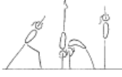 | - keep hips in line with hands during the handstand  - support phase  - stretch up first then open shoulders to initiate the bridge  - keep gluteal muscles tight  - maintain good body tension and alignment  - head neutral  - use the muscles in the legs and hips to stand
 | 7. F4-1.1 From stand, start with 1 leg raised perform a bridge onto a raised surface and return to stand | 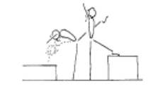 | - arms by ears with eyes looking at hands  - use shoulder and hip flexibility  - straight arms throughout the skill
 | 8. F4-1.4 Perform the walkover with some assistance from a coach | 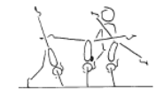 | - arms by ears with eyes looking at hands  - use shoulder and hip flexibility  - straight arms throughout the skill  - pass through a vertical handstand position with legs in stride
 | 8. ®* Fwd or Bwd Walkover | 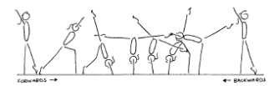 | - arms beside ears during all phases of the skill, with eyes looking at hands  - front walkover and tic-toc must pass through a vertical handstand prior to opening the shoulder angle to  - allow the bridge to occur (back walkover must start in a vertical stand before going back into the bridge phase)  - 180’ split of legs during the skill  - keep back and/or front legs still during scale phase  - arms straight, thumbs parallel and together  - the bridge action uses the hip and shoulder flexibility  - maintain good body tension and alignment  - square hips and shoulders throughout the skill
Hurdle | 1. F4-2.4 Continuous hurdles across the floor – ensure the correct position | 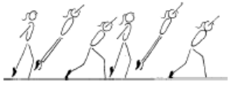 | - maintain good body tension and alignment  - chest in, hips under  - arms by ears  - generated power and forces  - head neutral
Handspring | 1. F4-4.1 Lunge from 1 step, into a fast handstand to a supersoft mat against the wall | 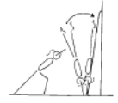 | - maintain good body tension and alignment  - repulsion from hands occurs when the body is travelling upwards with the heel drive  - land in an arch shape with arms by ears  - head neutral with eyes looking at hands
 | 2. F4-4.2 Same as F4-4.1 onto 2 supersoft mats
 | 3. Fast handstand on box – coach spots gymnast through handspring position to finish on feet
Flic Flac | 1. F4-3.3 From handstand on a raised surface, perform a fwd body snap, bounce on the floor to stand on the raised surface |  | - maintain body tension and alignment  - head neutral  - hands slightly turned in  - shoulders remain over the initial support position  - bounce from the floor
 | 2. F4-3.4 From a handstand move from an arch to a dish, may need assistance (can be done between p-bars) | 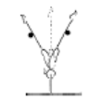 | - maintain body tension and alignment  - head neutral  - move from arch to dish
 | 3. F4-3.1 Awareness – coach lifts gymnast through ideal model (or over cylinder) | 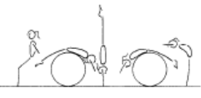 | - maintain body tension and alignment  - head neutral  - hands slightly turned in on contact  - emphasise initial starting and finishing position
 | 4. F4-3.2 Repeat F4-3.1 from a rebound surface | 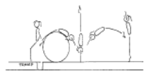 | - maintain body tension and alignment  - head neutral  - hands slightly turned in on contact  - emphasis initial starting and finishing position
 | 5. Spotted flic uphill – land on belly on supersoft mat

LEVEL 3 BARS (1)
Tuck Swings /Glides | 1. ® © From box or floor – 1 x tuck swing, 1 x Glide swing, return to floor | 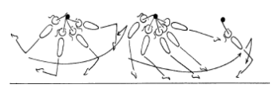 | - show a rounded body position on the jump to catch the bar, head neutral, chest rounded and hips under  - straight arms throughout the swing  - chest rounded and hips under throughout the swing  - the swing should gain amplitude  - a slight ‘tap’ action should be evident  - ‘dish’ shape at the start of the glide swing  - feet close to the floor during the glide swing  - toes swing to bar height at the peak of the ascent phase of the glide swing, hips open  - land safely at the back of the swing
 | 2. ®* From box or floor – 2 x Glide Swings, return to floor
Front Support /Casts | 1. ® © Cast to 45’ below horizontal (toes to bar height) |  | - Strong pike to strong heel lift  - Straight body  - Chest in  - Hips open at top of cast
 | 2. ®* Cast to horizontal | 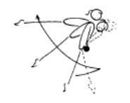 | - straight arms throughout the cast  - bring feet in front of the bar to initiate cast  - tip shoulders forward slightly  - cast feet backward and upward with a strong backward body snap  - straight body position at the ascent peak of the cast  - head neutral  - maintain good body tension and alignment during all phases of the cast  - return to the bar
Fwd Roll Dismount | 1. Fwd roll to L hang – hold for 3 secs
Pullover | 1. ® © Pullover to front support | 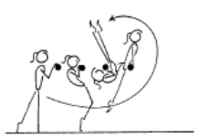 | - fast rotation around the bar  - toes and hips to the vertical line early  - keep head neutral  - move wrists around the bar quickly  - maintain good body tension and alignment  - finish in good front support
Back Hip circle | 1. B3-1.4 from a jump on a mini tramp to clear front support perform a back hip circle | 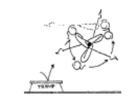 | - bring hips and feet under the bar fast  - fast rotation  - head neutral  - maintain good body tension and alignment  - fast wrist action on completion of circle
 | 2. ® © Backward hip circle | 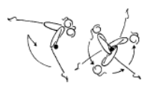 | - maintain good body tension and alignment  - arms straight  - head neutral  - after the cast the shoulders move backward whilst the feet move down, forward then upward  - push chest back  - rotation should be even and smooth  - wrists move quickly on completion of the circle  - finish in front support

LEVEL 3 BARS (2)
Toe Shoot Dismount | 1. B3-2.4 From a low box jump feet on the bar, swing under and immediately dismount | 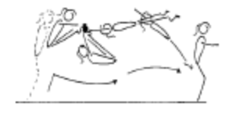 | - ensure good closure  - balls of the toes on the bar  - release near horizontal
 | 2. Cast to straddle on boxes
 | 3. B3-2.5 Gymnast climbs into straddle position on the bar and swings under to dismount
 | 4. B3-2.5 From front support, cast and place the feet on the bar, coach may support gymnast at this point, swing under to dismount | 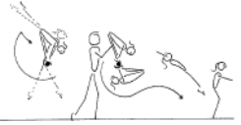 | - ensure good closure  - balls of the toes on the bar  - ensure the gymnast is confident
 | 5. ® © Underswing or Toeshoot underswing dismount | 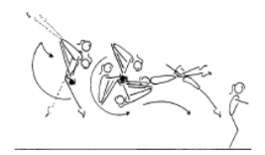 | - during the cast the body extends  - at the peak of the cast the feet move toward the bar as close to the hands as possible  - the path of the feet should be down and almost under the bar  - place the feet on the bar as late as possible  - the hips are far away from the bar as possible  - a tight closure should be visible, chest on legs  - powerful swing around the bar and extend body for flight off
Cast to Squat | 1. B4-2.3 Stoop, straddle & squat on a low floor bar, stand up and jump off
 | 2. B4-2.3 Climb to squat, hold for 2 seconds on the bar, stand with control and jump off
Long Swings & Long Swing Pullover | 1. ® © 3 x Beat Swings on high bar (arch then dish) | 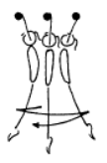 | - head neutral  - relaxed shoulders  - arms straight  - strong rhythm  - swings get bigger  - maintain good body tension and alignment  - regrip the bar on the back swing (when the body is in dish shape)
 | 2. B3-4.3 Swing between the bars with a mat over the low bar, gymnast should be able to swing above the low bar to prepare for a good tap between the bars and show a “kicking action” | 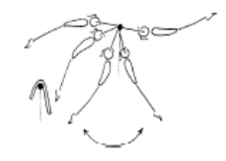 | - ensure a good understanding of the key shapes  - evident power generated from strong tap forward and backward  - maintain good body tension and alignment  - drive feet back under the low bar early to set the early tap
3. B4-5.1 Chin up pullovers x 7

4. Tuck swing pullover on low bar
 | 5. 3 x Tap swings on High bar (from kick start) (*) | 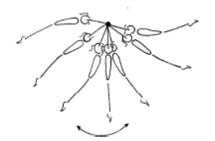 | - smooth rhythm  - swing should gain amplitude  - strong forward tap  - strong backward tap
Kickstart | 1. 7 x Leg Lifts on high bar – straight legs
 | 2. Holding toes to the bar in a pike position – shoot toes to roof (assisted) x 7
 | 3. On high bar, raise toes up to bar, bounce down to arch

LEVEL 3 BARS (3)
Kips | 1. B4-4.2 Front support flexion/extension activity with coach | 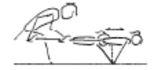 | - strong shoulder action  - chest in  - maintain body tension and alignment  - head neutral
 | 2. B3-6.1 with two feet in a sling, sling kip to front support x 5-10 | 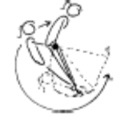 | - feet together with only one foot in the rope  - straight arms  - chest in, hips under, head neutral  - perform 5 - 10 in a series
 | 3. B4-3.3 Coach holds gymnasts feet in straddle position, and assists gymnast to complete kip from a ‘to and fro’ swing to establish rhythm | 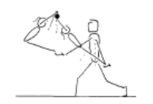 | - learn to “feel the rhythm” of the skill  - keep arms locked  - efficient kip action (hip extension)  - head neutral
 | 4. B4-3.2 short kip from lying on a raised surface – coach spots | 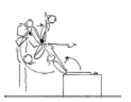 | - straight arms throughout  - keep shoulders open when snapping feet to the bar  - close shoulders strongly and initiate kip action (hip extension)  - efficient hip extension (opening)  - don't open hips all the way - must finish in closed pike position  - head neutral
 | 5. Straddle leg lifts – hanging on a high bar. Show star, rotate hips under through straddle position and up to touch bar x 7
 | 6. B4-3.4 – Drop kip (may be assisted) – used to develop strength in kip action and to improve the ‘rhythm’ of the skill | 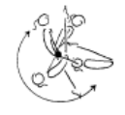 | - commence in a strong front support shape  - maintain shape during swing down  - keep arms locked  - bring the feet to the bar as the shoulders swing around the bar  - relaxed shoulders  - efficient kip action (hip extension)  - head neutral  - strong shoulder flexion then occurs  - move the wrists on top of the bar
 | 7. B3-5.4 Glide 2 feet into basket hang, return to stand | 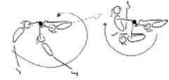
Cast to Handstand | 1. Cast to horizontal, push away to stand on box – repeat x 10

LEVEL 3 BEAM (1)
Squat On Mount | 1. ® © Squat on side or end of beam – stand | 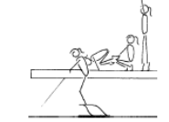 | - place hands on the Beam prior to take off  - square hips and shoulders throughout the skill  - vertical take off the board  - squat position performed on toes  - head up, eyes down  - control of body
Arabesque /Posture | 1. Arabesque (back leg min 90’, held 2 sec)
Releve/Turns | 1. ® © ½ turn on 2 feet | 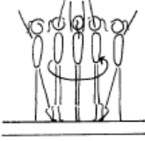 | - legs straight  - turn to be performed on toes  - hips under, stomach pulled in  - head up, eyes down  - spot the end of the Beam prior to turning , then spot the other end of the Beam on the completion of the  - turn  - good rhythm  - stable balance  - turn whole body as one unit  - Arms may be up or down
 | 2. ® © ½ turn on 1 foot – free leg in fwd passe |  | - Show passé position  - Straight Legs  - Turn on relevé  - Straight posture  - Turn entire body as one
Jumps /Leaps | 1. ® © Assemble, 2 x straight jumps – change feet – R/L |  | - Step fwds into assemble extending legs and joining feet in the air  - hips open & chin up  - Stretched position in straight jumps  - Good height  - Legs together
 | 2. 2 x step hops with straight leg – R&L
 | 3. ®* Stride jump 135’
 | 4. Tuck jump
Stride Leap | 1. ® © 1 x high fwd kick right, 1 x high fwd kick left (min horizontal) | 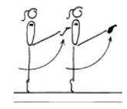 | - good rhythm  - good posture  - free leg lifted to hip height minimum  - arms are horizontal  - kicks performed on toes if possible  - support leg locked out
 | 2. ®* 2 x fwd kicks then 2 x bwd kicks – R/L (min horizontal)
 | 3. Step kick & hop – hold leg up – land with bent supporting leg and hold
 | 4. Landing position jumps along beam – back leg held
 | 5. ® © 2 x leap progressions R/L – landing leg to plie, back leg to horizontal |  | - Swing leg forward, 45° to the beam  - Spring from support leg  - Show amplitude and distance  - Land on bent leg with free leg in momentary rear scale
 | 6. Stride Jumps on mid beam with mat over/under
Body Wave | 1. ® © Fwd Body Wave |  | - Arch body forwards as arms softly accentuate wave  - Body fully flexed at the hip angle  - Raise & contract chest, arms lifting  - Extend arms to side with precision  - Arch back with arms and head

LEVEL 3 BEAM (2)
Handstand | 1. ® © “L” Handstand | 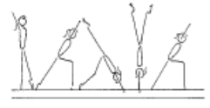 | - shoulders and hips square  - hips under, chest in  - head neutral  - one leg vertical, lunge leg at 90’  - finish in a lunge
 | 2. M3-4.4 Perform a full handstand step in on a bench, low beam
 | 3. ®* Handstand step in
BWO, FWO &  Tic Toc | 1. M4-3.1 Spotted BWO on the Floor | 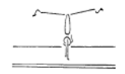 | - arms beside ears during all phases of the skill  - front walkover and tic-toc must pass through a vertical handstand prior to opening the shoulder angle to  - allow the bridge to occur (back walkover must start in a vertical stand before going back into the bridge phase)  - 180’ split of legs during the skill  - keep back and/or front legs still during scale phase  - arms straight, thumbs parallel and together  - the bridge action uses the hip and shoulder flexibility  - maintain good body tension and alignment  - square hips and shoulders throughout the skill
 | 2. M4-3.2 Spotted BWO on a line on the floor | 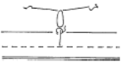 | - arms beside ears during all phases of the skill  - front walkover and tic-toc must pass through a vertical handstand prior to opening the shoulder angle to  - allow the bridge to occur (back walkover must start in a vertical stand before going back into the bridge phase)  - 180’ split of legs during the skill  - keep back and/or front legs still during scale phase  - arms straight, thumbs parallel and together  - the bridge action uses the hip and shoulder flexibility  - maintain good body tension and alignment  - square hips and shoulders throughout the skill
 | 3. M4-3.3 Spotted BWO on a low bench with mat | 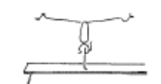 | - arms beside ears during all phases of the skill  - front walkover and tic-toc must pass through a vertical handstand prior to opening the shoulder angle to  - allow the bridge to occur (back walkover must start in a vertical stand before going back into the bridge phase)  - 180’ split of legs during the skill  - keep back and/or front legs still during scale phase  - arms straight, thumbs parallel and together  - the bridge action uses the hip and shoulder flexibility  - maintain good body tension and alignment  - square hips and shoulders throughout the skill
 | 4. M4-3.4 Spotted BWO on a beam with a mat | 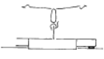 | - arms beside ears during all phases of the skill  - front walkover and tic-toc must pass through a vertical handstand prior to opening the shoulder angle to  - allow the bridge to occur (back walkover must start in a vertical stand before going back into the bridge phase)  - 180’ split of legs during the skill  - keep back and/or front legs still during scale phase  - arms straight, thumbs parallel and together  - the bridge action uses the hip and shoulder flexibility  - maintain good body tension and alignment  - square hips and shoulders throughout the skill
 | 5. M4-3.5 Spotted BWO on a low beam with stacked mats | 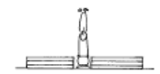 | - arms beside ears during all phases of the skill  - front walkover and tic-toc must pass through a vertical handstand prior to opening the shoulder angle to  - allow the bridge to occur (back walkover must start in a vertical stand before going back into the bridge phase)  - 180’ split of legs during the skill  - keep back and/or front legs still during scale phase  - arms straight, thumbs parallel and together  - the bridge action uses the hip and shoulder flexibility  - maintain good body tension and alignment  - square hips and shoulders throughout the skill
 | 6. M4-3.6 Spotted BWO on the low beam | 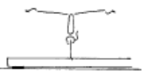 | - arms beside ears during all phases of the skill  - front walkover and tic-toc must pass through a vertical handstand prior to opening the shoulder angle to  - allow the bridge to occur (back walkover must start in a vertical stand before going back into the bridge phase)  - 180’ split of legs during the skill  - keep back and/or front legs still during scale phase  - arms straight, thumbs parallel and together  - the bridge action uses the hip and shoulder flexibility  - maintain good body tension and alignment  - square hips and shoulders throughout the skill

LEVEL 3 BEAM (3)
Cartwheel | 1. M3-4.5 Side handstand on low bench/beam against wall
 | 2. M4-4.2 Against a wall, cartwheel to stop at vertical, coach assists with ¼ turn to step down to lunge | 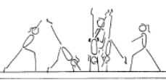 | - the 1/4 turn must occur immediately after vertical  - shoulders and hips must be square  - head in, eyes looking for the Beam
 | 3. M4-4.1 Rocking in side handstand on low beam with a coach spotting | 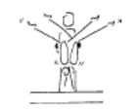 | - legs no more than 90’ straddle  - weight transfers from one hand to the other  - rock whole body as one unit  - maintain body good tension and alignment
 | 4. M4-4.3 Cartwheel on the low beam to land on a wider surface | 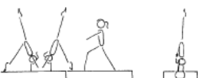 | - the 1/4 turn must occur immediately after vertical  - shoulders and hips must be square  - head in, eyes looking for the Beam  - land in a lunge
 | 5. M4-4.4 Cartwheel on a low bean with a light mat then without
Punch Set D/Mt | 1. ® © 3-4 steps, hurdle, punch jump dismount from 2 feet | 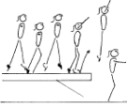 | - maintain balance during the running steps  - running steps must be on toes and lean slightly forward  - punch (or bounce) from both feet, toes, ankles and knees extended  - vertical take off angle  - maintain good body tension and alignment  - square hips and shoulders throughout the skill  - control during landing

LEVEL 3 VAULT (1)
Bounce /Spring | 1. Ankle raises x 20 with both feet then 15 on each leg
 | 2. V1-5 Springing Circuit – variety of 8 objects | 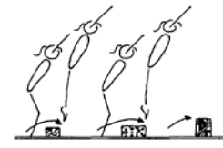 | - maintain good body tension and alignment  - continuous bouncing, no pauses or stops  - easy clearance of the objects
 | 3. Skipping rope x 50
 | 4. V2-4 Run, spring onto a 60cm box & immediately rebound off with a straight jump to land
Running | 1. V3-3.3 hopping (or skipping) – skip along the mat demonstrating the “perfect” running technique during the peak of each skip | 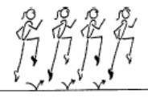 | - head neutral  - extend through ankles and toes  - lift knees to hip height with a fast powerful action  - arms in line with body
Hurdles | 1. Hurdles on Board – correct arms
Handstand Pop | 1. V3-4 Handstand pop on the floor – spotted | 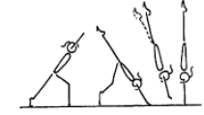 | - head neutral  - hands contact the floor early  - the ‘pop’ (push or bounce) occurs as the body is travelling upwards with the heel drive  - feet join prior to vertical  - maintain a strong handstand on landing
Catsprings -Handspring Vault | 1. V3-1.1 Handspring flatback from a board to 1 supersoft mat | 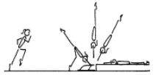 | - underarm action  - tight body in afterflight  - maximum air time  - hands contact board or rebounder early, with  - shoulders fully extended  - fast heel drive (backward body snap)
 | 2. V2-2 Cat springs on floor | 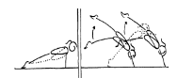 | - arms straight  - good spring  - continuous springing action  - fast explosive action off the floor  - slight stretch through legs and hips
 | 3. Clap pushups with feet on a box and hands on floor
 | 4. Straddle vault over horse (low setting)
 | 5. Squat vault over horse (low setting)
 | 6. “Blocks” onto 60cm box or mat | 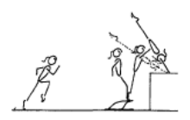 | - low hurdle - to capitalise on speed generated in the run  - contact the board slightly leaning backwards with only minimal flexion of hips and knees  - circle arms down the sides to thrust vigorously forward and upwards so that hands contact the horse as early as possible during the ascent phase
 | 7. “Blocks” onto 90cm box, mat or table
 | 8. ® ©Short run, handspring from board to land flatback on 60-90cm crashmat (hands on mat) | 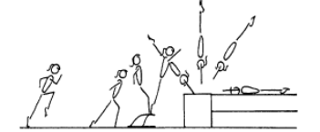 | - fast run  - low hurdle  - underarm action  - repulsion is instantaneous  - dynamic  - fast heel drive (backward body snap)  - hands contact vault early during the upward phase  - maximise air time in after flight  - good body tension throughout - legs straight and together, arms straight, head neutral

LEVEL 3 VAULT (2)
Dive Roll / Front Salto | 1. V3-2.1 Hold a dish shape on the floor with feet against a wall
 | 2. V3-2.6 Dive roll from the floor over small shapes onto one supersoft mat
 | 3. V3-2.5 From a short run, using a bench and a board dive roll onto one supersoft mat
 | 4. V3-2 Dive roll onto 60cm
5. V4-1.1 – 1.5 (tramp)
1.1 Back drop to feet
1.2 Hands + knees front salto to back drop to feet
1.3 Hands + knees front salto to feet
1.4 From feet front salto to back drop to feet
1.5 Front salto to land on a soft mat placed on the tramp after take off
 | 6. Spotted front saltos off mini/double mini
 | 7. ®* Short run, hurdle with arm circle, tuck front salto to 60cm (*) | 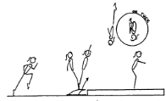 | - fast run  - low hurdle  - underarm action  - fast rotation  - maximum air time  - good body tension throughout  - dynamic  - shoulders travel vertical on take-off  - fast heel drive (backward body snap)  - on landing the hips, knees and ankles joints flex to absorb the landing

